ORBIT
Mobile App — Wireframe Screenshots
Low-fidelity wireframes · Figma · 6 screens
Prepared by shreya pawar

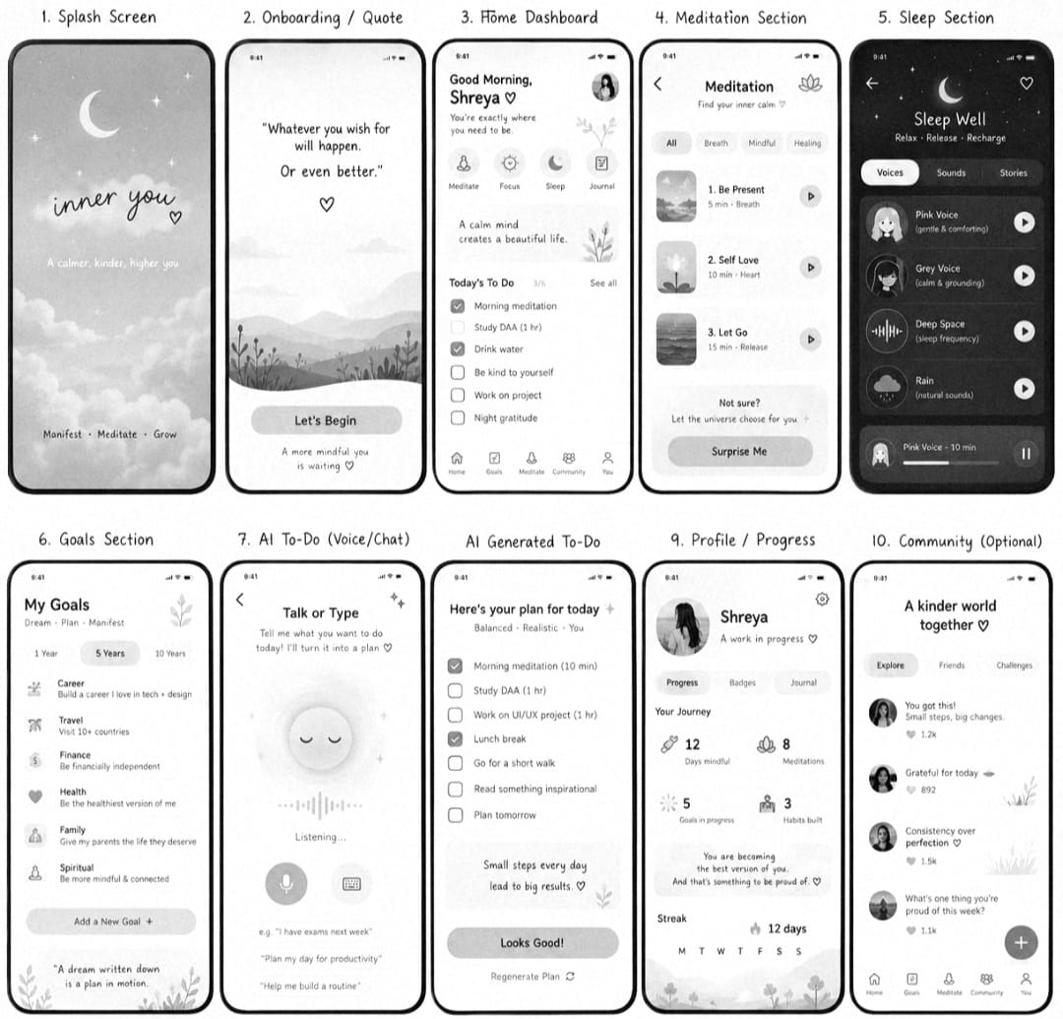

Screen 00 — Welcome

First-touch screen introducing the Orbit brand mark and tagline. A single primary action ("Begin") drives new users into onboarding, with a secondary text link for returning users to reduce friction at the entry point.
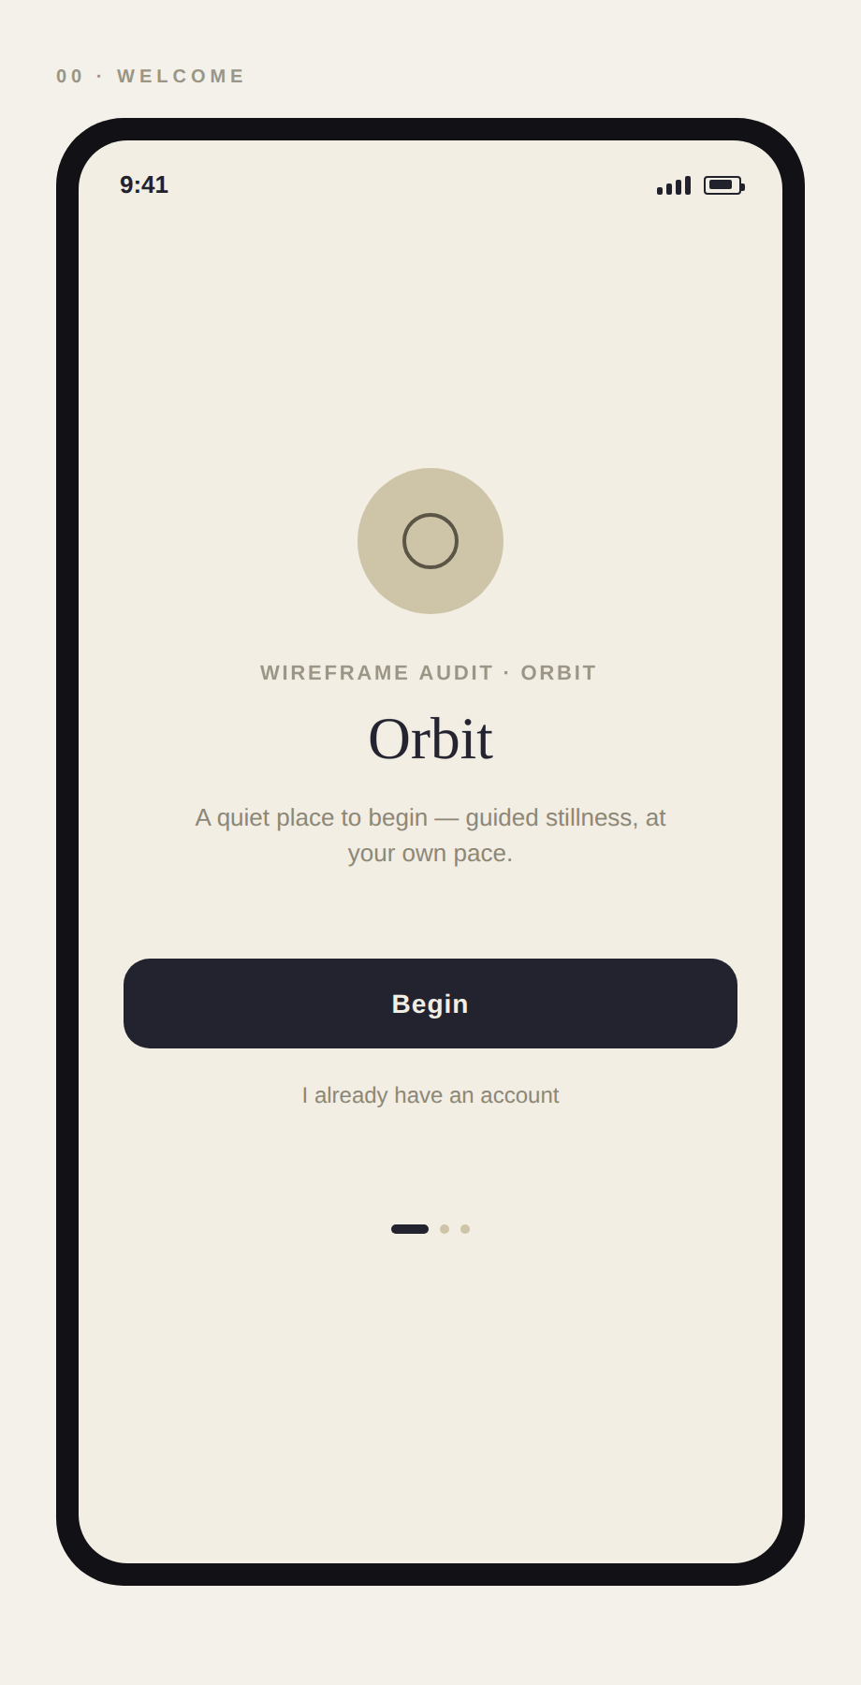

Screen 01 — Intent Selector
Branches the experience by self-reported experience level (curious / occasional / advanced). Each option previews the resulting path so the choice feels informed rather than arbitrary, and personalizes the content library shown later.
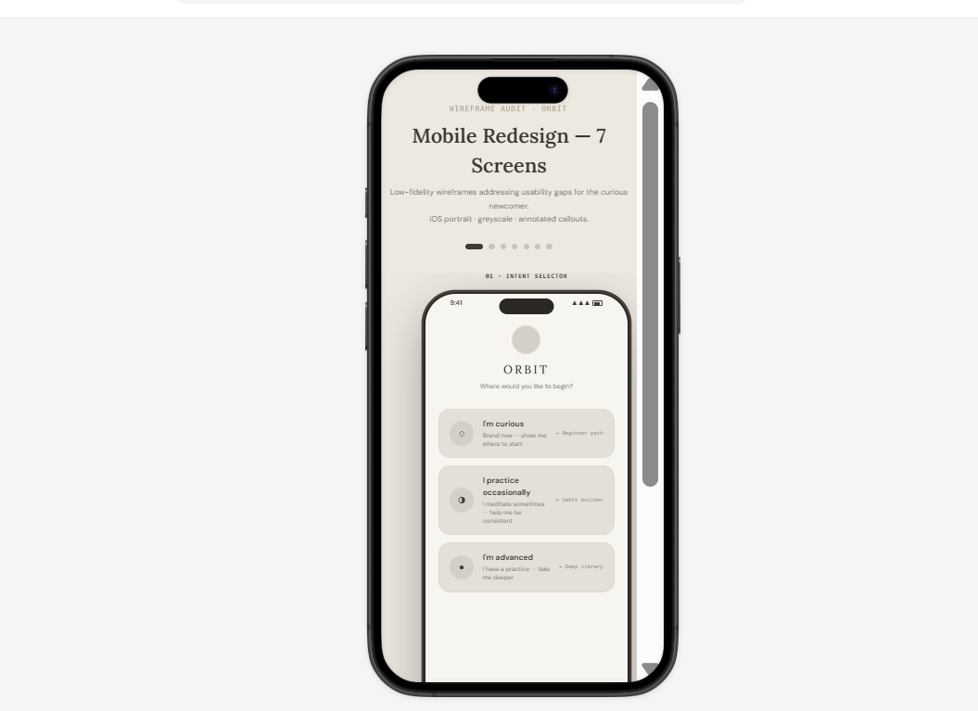

Screen 02 — Home
Daily landing screen combining a streak/motivation card, a "continue your path" queue of in-progress sessions, and a short reflection prompt. Bottom navigation anchors the four core sections of the app.
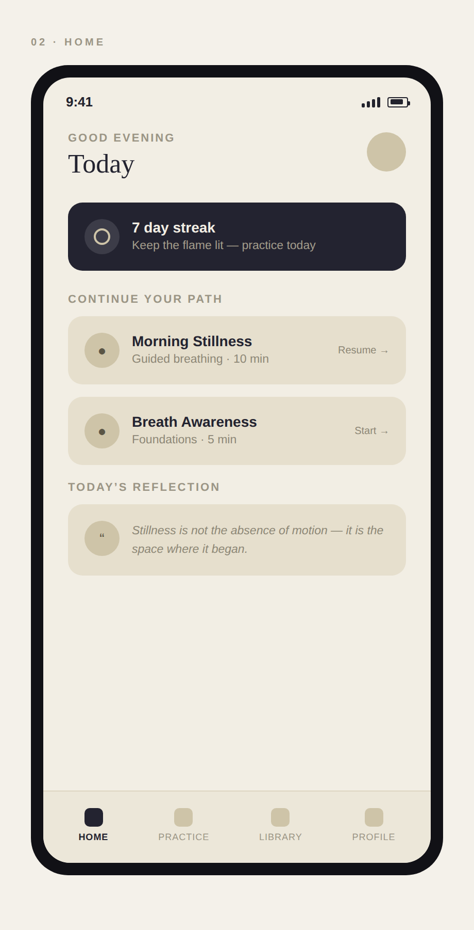

Screen 03 — Meditation Player
Core practice screen with a circular countdown timer, transport controls, and a waveform indicator for guided audio. Ambient/voice/silence mode toggle sits below the fold to keep the primary control uncluttered.
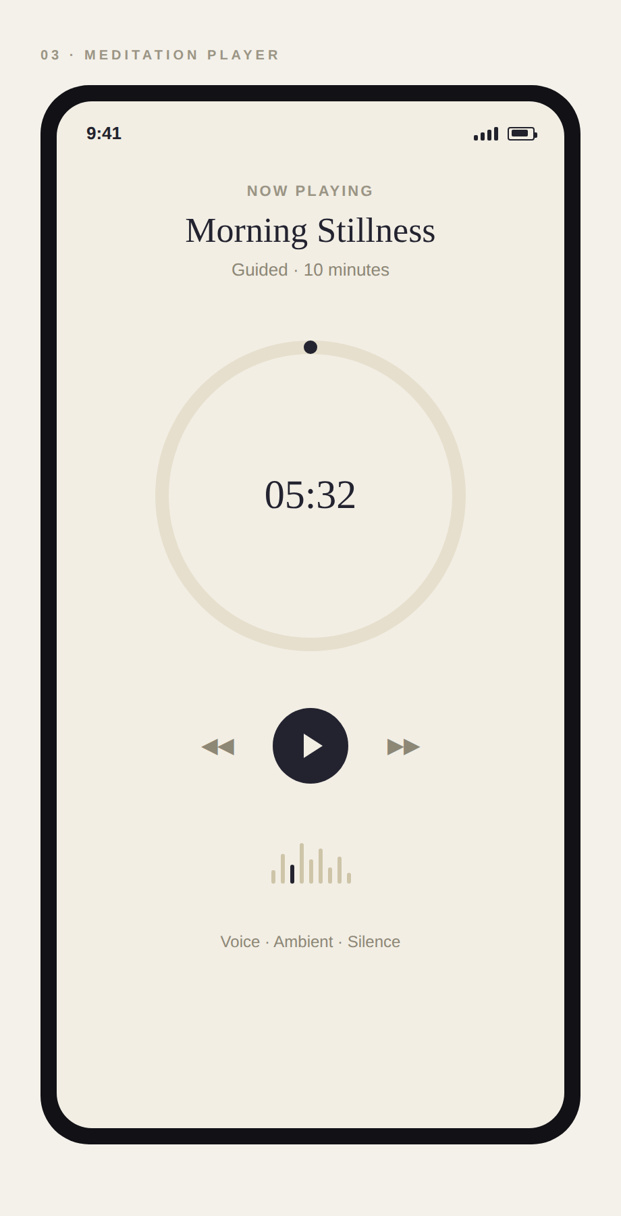

Screen 04 — Library
Browsable catalogue of sessions with a search field and topic filter chips (Sleep, Anxiety, Focus). List items surface duration and teacher name up front to support quick scanning and decision-making.
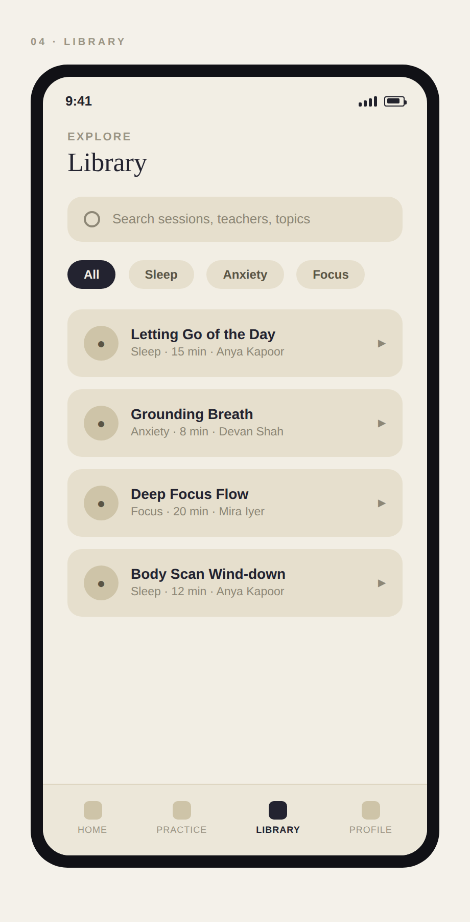

Screen 05 — Profile
Personal progress summary — sessions completed, hours practiced, and streak — alongside an achievements row and account settings list. Reinforces habit-building through visible, low-effort progress tracking.
